**Tunnel of Gold**

1. Create the following Background as a bitmap.

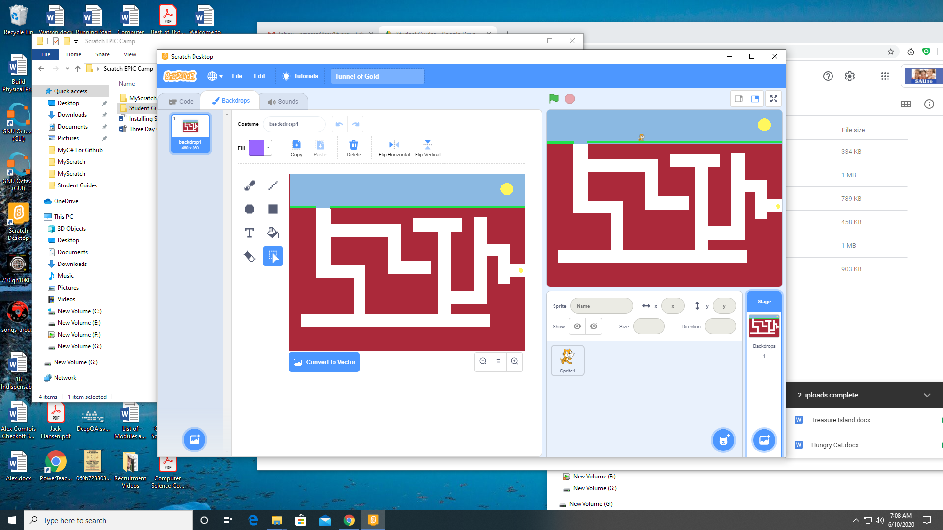

1. Scale Sprite 1(the cat) to 15% and orient on the stage.



1. Add the Music extension to your project.
2. Add the following code to Sprite 1 (the cat).

